U18CO018

Shubham Shekhaliya

Computer Graphics

Assignment-4

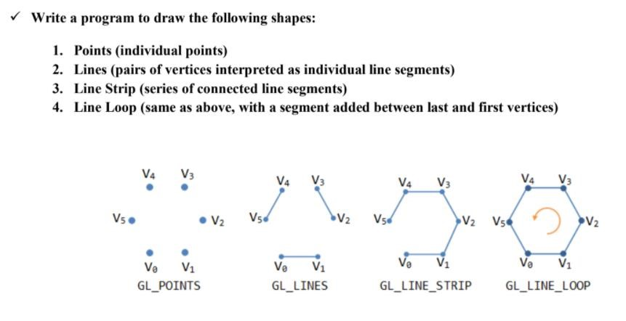

**Code:-**

#include<windows.h>

#include<stdio.h>

#include<GL/glut.h>

#include<math.h>

void init() {

glClearColor(1.0, 1.0, 1.0, 1.0);

glColor3f(0.0, 0.0, 1.0);

glPointSize(7.0);

glMatrixMode(GL_PROJECTION);

glLoadIdentity();

gluOrtho2D(-780, 780, -420, 420);

}

void display() {

glClear(GL_COLOR_BUFFER_BIT);

glEnable(GL_POINT_SMOOTH);

glBegin(GL_LINE_LOOP); // Change argument for different shapes

glVertex2f(0, 0);

glVertex2f(150, 0);

glVertex2f(225, 105);

glVertex2f(150, 210);

glVertex2f(0, 210);

glVertex2f(-75, 105);

glEnd();

glFlush();

}

int main (int argc, char** argv) {

glutInit(&argc, argv);

glutInitDisplayMode(GLUT_SINGLE | GLUT_RGB);

glutInitWindowSize(683, 384);

glutInitWindowPosition(0, 0);

glutCreateWindow("Points");

init();

glutDisplayFunc(display);

glutMainLoop();

return 0;

}

* **GL_POINTS**

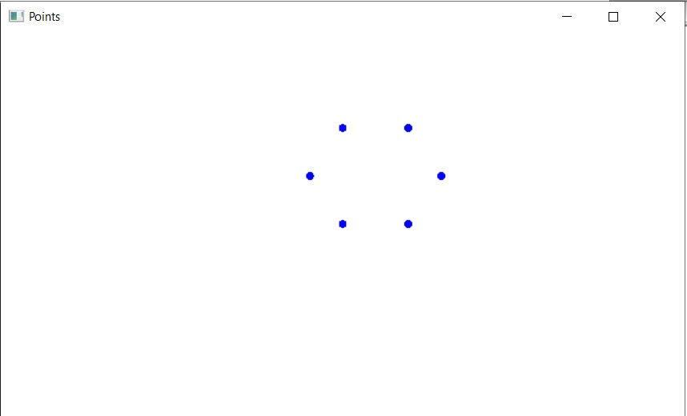

* GL_LINES

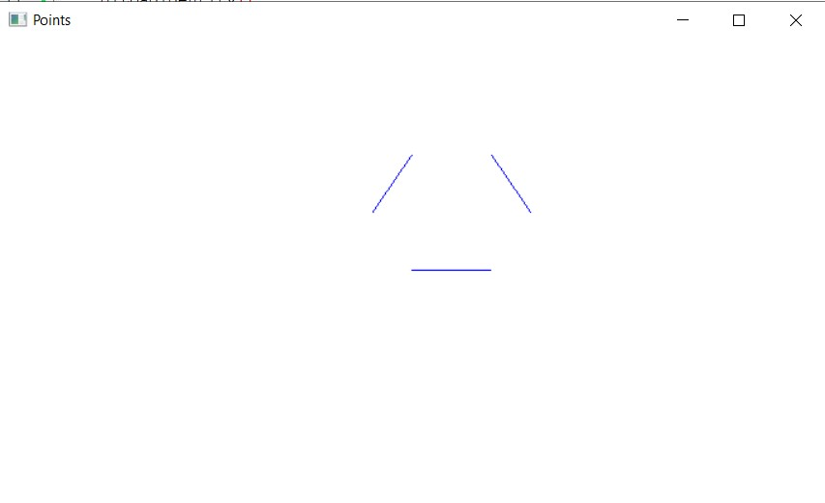

* **GL_LINE_STRIP**

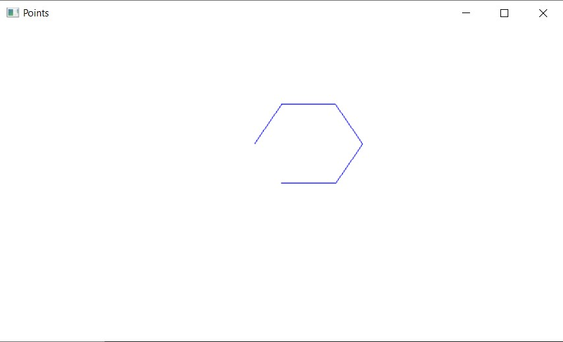

* **GL_LINE_LOOP**

